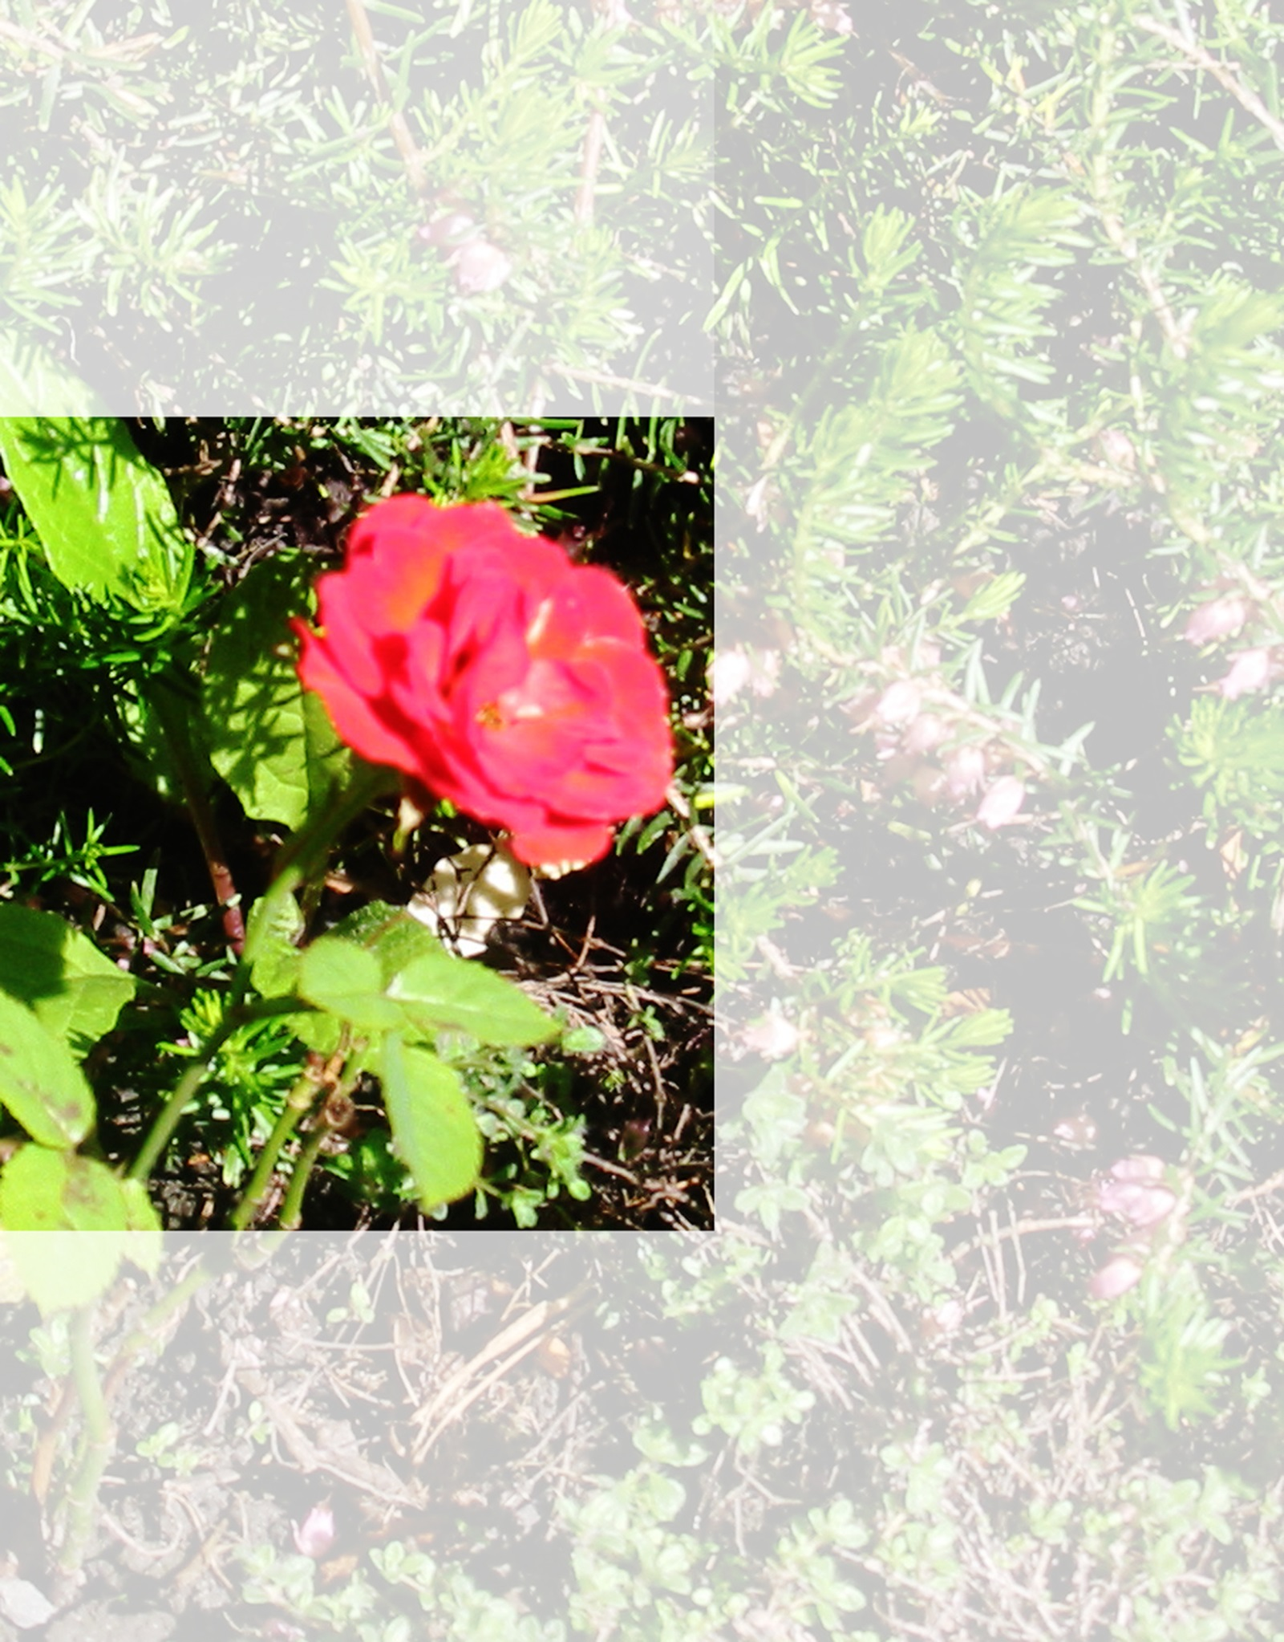
Hebden Poetry
Friends of
Station
Hebden Bridge
Enjoy
We invited local poets to share a favourite poem with us. www.hbstationfriends.org.uk
Journey
The train left the station without me-
I was at home knitting my suitcase
I wove old travel passes into it
and tickets with the names of distant towns
to which I’d travelled and returned.
I had meant to pack inside it
A watertight solution to anxiety
and the memoirs of my life
wrapped in a single red rose
its petals permanently perfumed
Eileen Wright


About Eileen Wright
Eileen moved North to Hebden Bridge in 1987 and simply cannot leave.
Her poems are published in the small press and various anthologies.
A cleaner, artist, film extra and performance poet
She runs the local workshop Writing Space.
She also has been, and often still is a Clown.

